
Patient Information
Patient Name
First:____________________________________________MI:___________Last:_________________________________________________

DOB:____/____/______ Gender: Male Female

Address:________________________________ City:________________ State:____ Zip:_______

Home Phone:______________________ Cell Phone:________________ Work Phone:______________________
Employer:_____________________________ Occupation:__________________________________
Complete below if the patient is a minor
Father’s Name____________________________
DOB:___/_____/_____ Phone#’s:__________________________________________________________________________
Mother’s Name___________________________
DOB:___/_____/_____ Phone#’s:__________________________________
Address:__________________________________
Guardian Name____________________________
DOB:___/_____/_____ Relation:_______________ Phone#’s:___________________________________
Address:____________________________________
Guardianship papers: Y / N
I give consent for above listed Guardian to accompany my child to appointment.
Print___________________________
Signature:_________________ Date:__________

Martial Status:__________________
Name of Spouse:_______________________________
Race
American Indian or Alaskan Native Asian
Native Hawaiian
Black or African American White
Other Pacific Islander Prefer not to answer
Ethnicity
Hispanic/Latino Non-Hispanic/Latino
Prefer not to answer
Preferred Language
English Spanish Arabic French Other

Pharmacy #1
Name:___________________________________Address___________________________________
Pharmacy #2
Name:___________________________________Address___________________________________
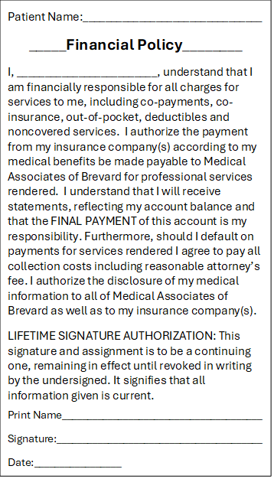
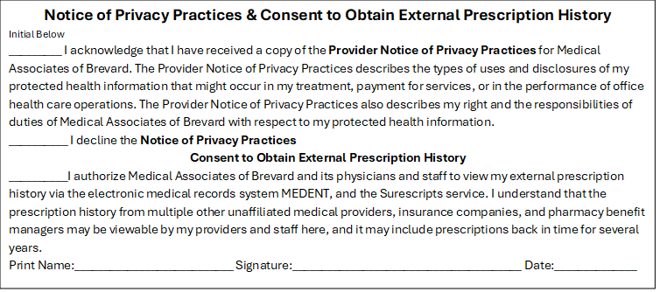
________HIPPA Disclosure______
I authorize Medical Associates of Brevard to discuss my healthcare information with:
Name:___________________________________________Relation:________________Phone#__________________
Name:___________________________________________Relation:________________Phone#__________________
Name:___________________________________________Relation:________________Phone#__________________

Preferred appointment reminder notification:
Home Phone Cell Phone Work Phone
With the person(s) authorized above

Preferred medical information notification. I authorize Medical Associates of Brevard to leave a detailed message on my answering machine/ voicemail and/or with the person(s) authorized above:
Home Phone Cell Phone Work Phone
With the person(s) authorized above

